

**Adama Science and Technology University**

**School of Electrical Engineering and Computing**

**Course Title:** Fundamentals of Electrical Engineering

**Course Number:** EPCE2101

**Lab:** Experiment Number 5

**Title:** Thevenin & Maximum Power Transfer

**Prepared by:**

**Name ID No.**

**Submitted To**: Lab Instructor Lemessa

**Date of conduction**: Apr,4,2023

**Date of submission**: Apr,11,2023

**Acknowledgement**

We would like to acknowledge our Lab assistant Mr.Lemmesa his support and explanation in the laboratory. Through the group work and experiment we were able to comprehend the topics that were raised and able to communicate with each other well.

**Objectives**

# At the end of this lab experiment, the students will be able to:

A ,To Verify (prove) Thevenin’s Theorem

B, To Verify (prove) Maximum Power Transfer Theorem

**Apparatus Required For Thevenin’s**

1. Dc power supply(1)
2. Fixed Carbon composition resistors of different values(3)
3. Variable resistor(2)
4. Analog and/or digital multimeters
5. Connecting wires

**Theorotical Background**

A, Thevenin’s Theorem

Thevenin’s theorem is a circuit analysis technique which reduces any complex linear bilateral network to an equivalent circuit having only one voltage source and one series resistor. The resulting two-terminal circuit is equivalent to the original to the original complex circuit when connected to any external branch or component. In summary Thevenin’s theorem states that;

“Any linear bilateral network may be reduced to a simplified two-terminal circuit consisting of a single voltage source (ETh) in series with a single resistor (RTh)” 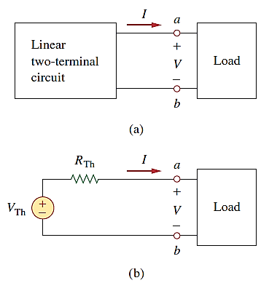

***Figure: Replacing a linear two-terminal circuit by its Thevenin equivalent:***

***(a) original circuit,***

***(b) the Thevenin equivalent circuit.***

To apply this idea in finding the Thevenin resistance, we need to consider two cases.

■**CASE 1:**If the network has no dependent sources, we turn off all independent sources. Rth is the input resistance of the network looking between terminals *a* and *b*.

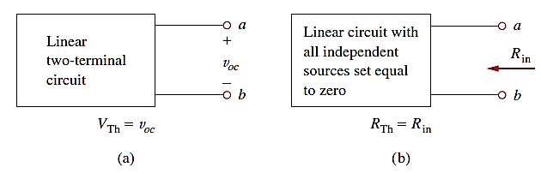

***Figure: Finding Vth and Rth***

■**CASE 2:**If the network has dependent sources, we turn off all independent sources. As with superposition, dependent sources are not to be turned off because they are controlled by circuit variables. We apply a voltage vo source at terminals *a* and *b* and determine the resulting current io. Then Rth = vo/io. Alternatively, we may insert a current source io at terminals *a*-*b* and find the terminal voltage vo. Again Rth = vo/io. Either of the two approaches will give the same result. In either approach we may assume any value of vo and io.

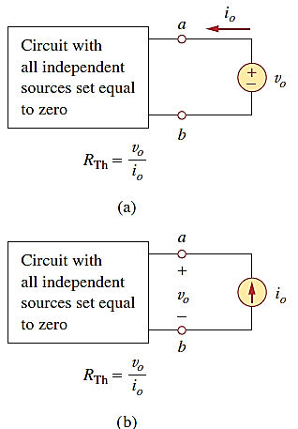

***Figure: Finding RTh when circuit has dependent sources.***

**Theoretical Background**

**B, Maximum Power Transfer**

The Maximum power transfer theorem states that;”A load resistance will receive maximum power from a circuit when the resistance of the load is exactly the same as the Thevenin resistance looking back at the circuit”.

We can determine the maximum power that a circuit can supply and a manner in which to adjust the load to effect maximum power transfer by using Thevenin’s theorem.

Given the circuit shown below.

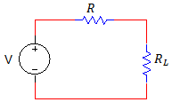

The power that is delivered to the load is given by the expression.

 



We want to determine the value of RL that maximizes the power. Therefore, differentiating this expression with respect to the load resistor RL, and equating the derivative to zero, we can obtain the value of RL for which the power becomes maximized.



Therefore, maximum power transfer takes place when the load resistance RL= R. The voltage source V and the resistance R could represent the voltage and the resistance in Thevenin’s equivalent circuit for any linear network.

Then, the max power transferred is



**Steps To Apply Maximum Power Transfer:**

**Step 1**: Remove the load resistance of the circuit.

**Step 2**: Find the Thevenin’s resistance (RTH) of the source network looking through the open-circuited load terminals.

**Step 3**: As per the maximum power transfer theorem, Rth is the load resistance of the network, i.e, RL=RTH that allows maximum power transfer.

**Step 4**: Maximum power transfer is calculated by the below equation (Pmax)=V2TH/4TH

**1.Procedure For Thevenin’s Theorem**

* 1. First we Assembeled the given circuit shown in fig 5.3a naming it R1= 326 ohm, R2= 3.26K ohm & R3=RL=660 ohm.

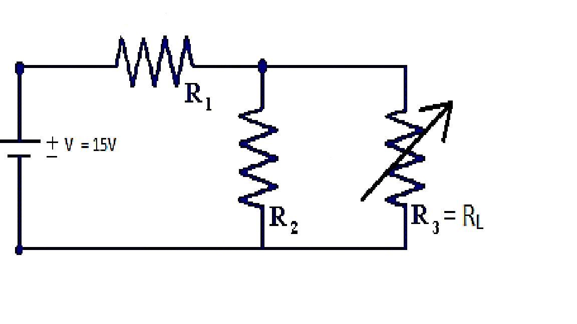 circuit (a)

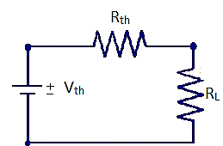 circuit (b)

* 1. Then we turned the power supply on and adjusted it to 15v using DMM
  2. After that we measure and calculate the load current and the load voltage of circuit(a), R3=RL
  3. Then We measured and calculated the Thevenin resistance, Thevenin voltage.
  4. After that we have adjusted one of the given variable resistor equal to Thevenin’s value.
  5. Then we have Assembled the Thevenin’s equivalent circuit as shown in circuit(b).
  6. Then we have measured and calculated the load current and the load voltage of fig 5.3b.
  7. Finally we recorded all measured and calculated results.

**2.Procedure For Maximum Power transfer**

2.1 First we take the values of Rth and vth in the Thevenin’s theorem and assembled the circuit as in Fig.5.4

2.2 Then we Adjusted the variable resistor at different values as indicated in the table 5.2

2.3 After that we measured the corresponding load current and load voltage and recorded them in table 5.2

2.4 Then we calculated the power delivered to RL for its different resistance values.

2.5 Finally we plotted a graph of PL as a function of RL & prove that maximum power delivered to the load at RL=RTH.



Figure 5.4

**Result and Discussion**

From the experiments we have done we have obtained the following measurements.

|  |  |  |  |  |
| --- | --- | --- | --- | --- |
| Thevenin’s Theorem | | | | |
| Table 5.1 | RTH | VTH | IL | VL |
| Calculated Values | 0.296k ohm | 13.63v | 14.25mA | 9.405v |
| Measured values for Fig5.3a | 0.302kohm | 13.59v | 13.57mA | 9.85v |
| Measured values for Fig5.3b | 0.28kohm | 13.67v | 13.84mA | 9.6v |

|  |  |  |  |
| --- | --- | --- | --- |
| Maximum Power Transfer | | | |
| RL Values/ohm | 0.2 | 0.26 | 1.09 |
| IL/mA | 20.15 | 22.2 | 9.5 |
| VL/V | 4.03 | 5.77 | 10.39 |
| PL/mW | 81.20 | 128.04 | 98.37 |

**Conclusion**

We have observed the following points about Thevenin’s theorem

We have observed the following points about the Maximum Power Transfer:

* The maximum power is dissipated when the varied load resistor is equal to the Thevenin resistor which is connected in series with it.
* So to get a maximum power across the load, we have to set the load resistance equal to Thevenin resistance.
* The powers before and after the when the load resistor is equal to Thevenin resistor are lesser than the maximum power.

**References**

* Fundamentals of Electric Circuits, C. K. Alexander and M. N. O. Sadiku